McKay, Festus Claudius “Claude” (1889-1948)

SUMMARY

Claude McKay was a Jamaican poet, novelist, essayist, activist, and editor. He is best known for his involvement in the New Negro movement of the early twentieth century (also known as the Harlem Renaissance). He helped introduce radical politics and a sophisticated use of Primitivism into African-American literature and wrote important political poems like “If We Must Die.” Today McKay is best known for his 1928 novel *Home to Harlem*. A lifelong traveler, he provided crucial connections between U.S. racism and international struggles. He also was an avid Marxist and associated with the Communist Party until late in life, when he converted to Catholicism. He angered and alienated writers, critics, and even friends with his aversion to the black elites and genteel literary critics. Long valued as an exponent of Primitivism in the Harlem Renaissance, in recent scholarship he has been recognized for his radical poetry, his writings in Jamaican *Patois*, his international efforts, and his theoretical considerations of race and gender to political struggles of black working people across and beyond the U.S.

MAIN ENTRY

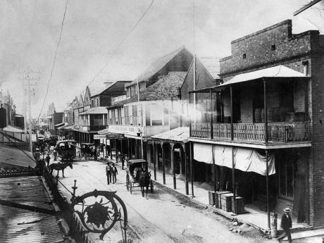Claude McKay was born in Sunny Ville, Jamaica. The youngest of Baptist middle-class farmers Thomas Francis McKay and Hannah Ann Elizabeth Edwards’ eleven children, he attended church schools and received additional training in classical English literature, science, philosophy, and theology.

[Rights: Jamaica Gleaner. URL: http://jamaica-gleaner.com/gleaner/20130719/news/news7.html ]

Downtown Kingston, Jamaica, in the 1890s.

At 18 his white mentor, a folklorist and critic of modernism named Walter Jekyll, encouraged McKay to write poems in Jamaican *Patois*, which appeared as *Songs of Jamaica*, a positive remembrance of his childhood in the Clarendon mountains, and *Constab Ballads*, an expression of McKay’s disillusionment with Kingston’s caste systems.

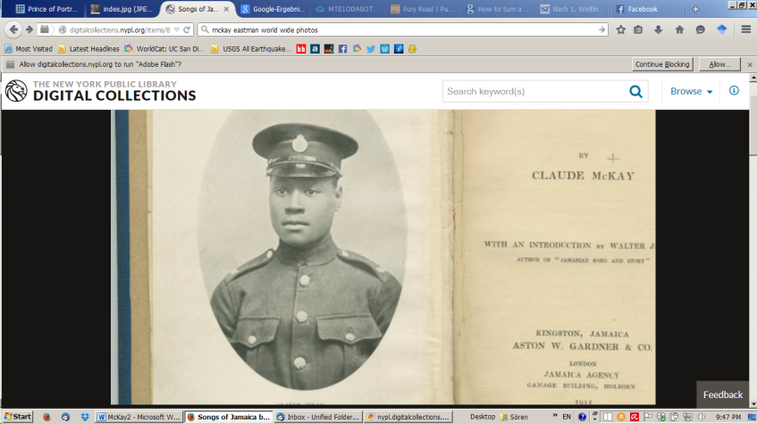[Rights: New York Public Library. Source: http://digitalcollections.nypl.org/items/8e0aac3d-a587-b26d-e040-e00a1806380e]

In 1912, McKay used the stipend from his national medal for poetry to move to the U.S. After some months at Tuskegee Institute and two years at Kansas State College, he left for New York, where he lived in Harlem and Greenwich Village. There, he worked odd jobs and wrote poetry, some under pseudonyms like Eli Edwards and Leon Lopez. The large city and its rough lack of classical rhythms inspired McKay in his search for artistic and bodily freedom, while at the same time providing a contrast to the nostalgia for his Jamaican childhood.

Claude McKay in his police uniform, ca. 1912, from *Constab Ballads*.

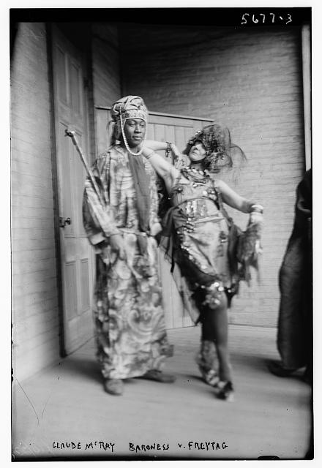

[Source: George Grantham Bain. Rights: LoC. Source: http://www.loc.gov/pictures/resource/ggbain.33941]

He joined the Industrial Workers of the World in July 1919 and would later be investigated by the FBI. That same summer he wrote his famous outcry against the wide-spread violence against black people, expressed through his thorough training in classical English literature. His sonnet “If We Must Die” became a poetic anthem for many black writers and an example of his careful politicization of both poetics and content. It illustrates his struggle to represent authenticity in a literary market divided along lines of class and race, most famously by never directly referring to the speaker’s race. This success, published in *The Liberator*, led to a connection with its editor Max Eastman, and later to McKay’s associate and co-editorship of the paper.

Claude McKay and the Dadaist poet Elsa von Freytag-Loringhoven, 1920s.

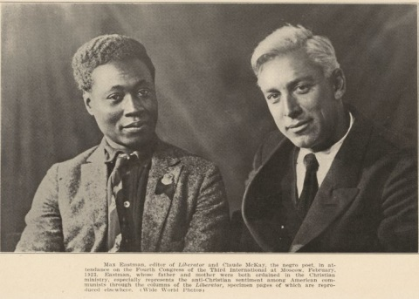

[Rights: Wide World Photos. Source: ]

McKay was always an international poet. Beyond his West Indian upbringing, he traveled extensively during the 1920s and 30s, staying and working in England, Holland, Belgium, Russia, France, Germany, Spain, and Morocco. He became a member of English socialist literary scene in 1919-21, where he worked for Sylvia Pankhurst’s *Workers’ Dreadnought* in London. He traveled to Soviet Russia in November 1922-3. There he met Leon Trotsky and Nikolai Bukharin during the Fourth Congress of the Third International in Moscow in December, and Alain Locke in Germany in 1923. Locke later included McKay’s poetry in his anthology *The New Negro* (1925).

Claude McKay and Max Eastman in Moscow, 1923.

[Source: “Mr. McKay Speaking in the Throne Room of the Kremlin” from Claude McKay's article “Soviet Russia and the Negro,” *The Crisis*, December 1923.]

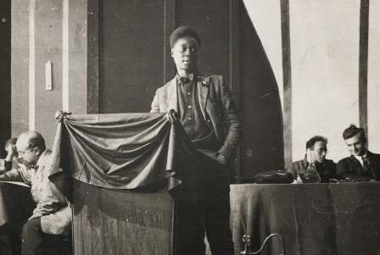

McKay’s poetry also appeared in *The* *Crisis*, *Opportunity*, and The *Nation*. Often classical in form and radical in content, it simultaneously pushed back against the promise of both Harlem and genteel critics by examining the sonnet’s colonial roots in the USA. McKay frustrated many of his contemporaries with his emphasis on personal taste and his consistent emphasis on the international dimension of racism. McKay stressed that the USA was a new imperial power and tried to place Jim Crow racism in an international context. He connected racist discrimination to workers’ uprisings and later directly contrasted the racist exploitation of African Americans with the freedom he experienced in Soviet Russia. His acclaimed *Harlem Shadows* (1922) gathered many of his poems, but not some of his most aggressive, political ones. The collected poems discuss racist and sexual violence, the pressure of white money on black communities, the commodification of art, and McKay’s nostalgia for his Jamaican home.

Claude McKay addresses Comintern, 1923.

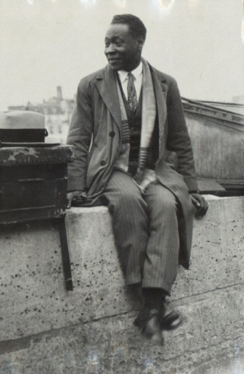[Source: Harry Ransom Center, U of Texas, Austin, William A. Bradley Literary Agency Records.]

Claude McKay in 1928, promotional picture for *Home to Harlem*.

Even though McKay was no Harlem native, and though he was abroad at the time, he wrote his most famous piece about Harlem during these years. *Home to Harlem*, originally conceived as a short story, was published in 1928 and won the Harmon Gold Award that year. Here McKay dives deep into the urban scene, nightlife, language, and social problems of working black Americans. Depicting a search for a common black culture and a home in a diasporic black world, the novel focuses on a deserter veteran of World War I, Jake Brown, whose proletarian perspective McKay contrasts with the more pessimistic perspective of Ray, an educated Haitian immigrant and advocate of black pride. Famously, Brown embraces a vital scene of burlesque, spectacular sensuality in bohemian Harlem, but it also criticizes black elites. McKay’s affairs with both black and white women and men, and his aversion to black bourgeois politics of racial uplift also led to clashes with elite literary circles and genteel authors and critics. Genteel black critics were offended by what they took to be McKay’s primitivism and decried his portrayal of the black working class and urban poor as a step back in uplift efforts. Prominent figures such as W.E.B. DuBois warned that McKay would ultimately only confirm white stereotypes and amplify racist prejudice.

McKay saw the natural beauty of black communities as aesthetically and socially revolutionary. His acceptance of black workers confronted racist stereotypes by stressing the natural vitality underlying black communities as an antidote against the corrupting influence of white civilization, its racist materialism, and its formulaic modernism.

Published the following year, *Banjo* follows Ray to the red-light district of Marseilles and its poor proletarians. More than a sequel to *Home to Harlem*, *Banjo* explodes the confines of racism in Harlem in a “story without a plot,” which follows Ray from the U.S. into the company of a rowdy cast of characters around the beach musician Banjo. McKay’s characters are no primitivist figures. He leverages their spontaneity, transience, international culture, creative complexity, and vivacious energy against French colonial rule and racism—a quality Aimé Césaire valued in *Banjo*. Though never published, the shorter *Romance in Marseilles* stays with this scene and indicates that McKay also considered non-normative sexuality as itself radical and anti-reactionary.

McKay stressed that the lives and desires of black people are part of a shared experience and that the struggle against racism is the same. He set the twelve short stories collected in *Ginger Town* (1932) in Harlem, Jamaica, the Mediterranean, and North Africa. His third novel *Banana Bottom* (1933) returns to this theme, the rejection of racist imperialism at home, in McKay’s imagined rural Jamaica. As the protagonist Bita Plant loses her Christian church mission and returns to the folk culture of her native village, she finds liberation in the assertion of her folk identity—an identity that, while idealized and romanticized, nevertheless manages to place Jamaican peasants in a global, proletarian struggle.

McKay returned to the USA in 1934, at the end of the Depression, and to a ruined market for African-American literature. He wrote *A Long Way from Home*, an autobiographical account of his travels that focuses on his artistic struggle with self, race, and class. It also forms the conclusion to his growing disillusionment with white orthodox Communism and a break with the Communist Party. Inspired by his friend Ellen Tarry, McKay increasingly turned to Catholicism after 1938. His collection of essays *Harlem: Negro Metropolis* is perhaps the most systematic treatment of Harlem history. It details the history of real estate, and of prominent religious leaders, especially Father Divine. The collection also examines political leaders—including Marcus Garvey, with whom McKay had a falling-out in the early 1920s—occult figures, immigrants, Prohibition smugglers and numbers racketeers, and labor organizers like Sufi Abdul Hamid.

[Title: “Claude McKay,” July 25, 1941. 10 by 7 7/8 inches. Taken by: Carl van Vechten. Rigths: Cedar Rapids Community School District. URL: http://www.iapublication.com/2012/10/02/cedar-rapids-2/]

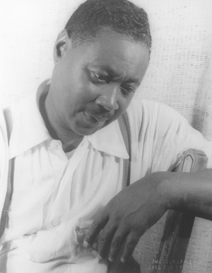McKay continued to suffer from life-long financial problems. His conflicts with the NAACP and Communist Party probably cost him his work with the Federal Writers Project. The life-long atheist converted to Catholicism and moved in 1944 to Chicago, where he worked with the Catholic Youth Organization under the progressive, pro-labor Bishop Bernard Sheil. The often blunt and argumentative McKay grew isolated and ill as he watched with concern the postwar rise to power of the USA. Two years before his death he completed his second autobiography, *My Green Hills of Jamaica*, containing a reverie of a pastoral, Edenic Jamaican childhood devoid of racism and abjection, along with an abbreviated defense of his conversion. Claude McKay died in Chicago on May 22, 1948. He was fifty-nine years old. His final collection of poems, *Selected Poems*, appeared posthumously in 1953.

Claude McKay, 1941.

Claude McKay was one of the first authors to capture and express the lives of the black working class and to politicize and connect their struggles in the USA to broader, international questions. Yet he never truly settled, literally or metaphorically, on an issue or a locale. A fierce defender of a shared humanity and the value of black culture, the self-described “vagabond poet” never abandoned his principled distrust of white elite modernism and refused to compromise his anti-racism and anti-imperialism. Until his death he refused to be labeled, controlled, or classified as part of the status quo.

List of Works

Poetry

*Songs of Jamaica* (1912)

*Constab Ballads* (1912)

*Spring in New Hampshire, and Other Poems* (1920)

*Harlem Shadows: The Poems of Claude McKay* (1922)

*Selected Poems* (1953)

*Complete Poems.* Ed. William J. Maxwell. (2004)

Selected Essays

“Soviet Russia and the Negro” *Crisis* (1923/24)

“Negry v Amerike” (1923). This was published as “The Negroes in America,” edited by Alan L. McLeod (1977).

“Sudom Lincha” (1925). This was published as “Trial by Lynching: Stories about Negro Life in North America,” edited by Alan L. McLeod (1977).

“A Negro to His Critics” (1932)

*Harlem: Negro Metropolis* (1940)

“Why I Became a Catholic” (1946)

Novels

*Home to Harlem* (1928),

*Banjo: A Story Without a Plot* (1929)

*Banana Bottom* (1933)

*Romance in Marseilles* (1929-32, unpublished)

Short Stories

*Gingertown* (1932)

Autobiography

*A Long Way from Home* (1937)

*My Green Hills of Jamaica* (1979)

Further reading

Cooper, Wayne F. *Claude McKay: Rebel Sojourner in the Harlem Renaissance: A Biography*. Baton Rouge: Louisiana State UP, 1987.

Tillery, Tyrone. *Claude McKay: A Black Poet’s Struggle for Identity*. Amherst: U of Massachusetts P, 1992.

James, Winston. *A Fierce Hatred of Injustice: Claude McKay’s Jamaican Poetry of Rebellion*. London: Verso, 2000.

Gosciak, Josh. *The Shadowed Country: Claude McKay and the Romance of the Victorians*. New Brunswick: Rutgers UP. 2006.

Holcomb, Gary Edward. *Claude McKay, Codename Sasha: Queer Black Marxism and the Harlem Renaissance*. Gainesville: UP of Florida, 2007.

Baldwin, Kate. *Beyond the Color Line and Iron Curtain: Reading Encounters between Black and Red, 1922-1963*. Durham: Duke UP, 2002.

Sören Fröhlich, University of California, San Diego